

**PUSL2003 Integrating Project**

**Project Proposal 2020/21**

Travelling items sell and rent Mobile Application.

Group Name: Elite

Members:

|  |  |  |  |
| --- | --- | --- | --- |
| ID | Name | workload | Degree Program (SE/CN/CS) |
| 10707202 | Sasindu Gamage | Background and motivation | SE |
| 10707193 | Ruhunu Fernando | Project Objectives | SE |
| 10707375 | Balage Silva | Project planner | SE |
| 10707297 | Godella Pathirana | Introduction | SE |
| 10707428 | Ran Yasiru | Resource Requirements | SE |
| 10707362 | Saunda Sanjula | Methdology | SE |

Contents

Introduction 2

Project objectives 3

Background and motivation 3

Methodology 4

• How does your application/solution differ from existing ones 4

• Benefits of the app to users 4

• Why do you think this will be a possible solution 4

Resource Requirements. 4

Project Planner 5

References 6

# Introduction

Sri Lanka travellers do not have any online platform to buy or rent travelling items. Therefore, We are trying to solve this problem by using new technology. We create an cross platform mobile application for travellers. using these app travellers can buy or rent any travelling item easily. Using the app travellers also can book hotel accomodations,cab services ,camping items,swimming related items which are needed for voyagers all around the world. Also travellers can know various tourist attractions which are very not popular among travellers.using the travelling app travellers can easily do their payments from one place.

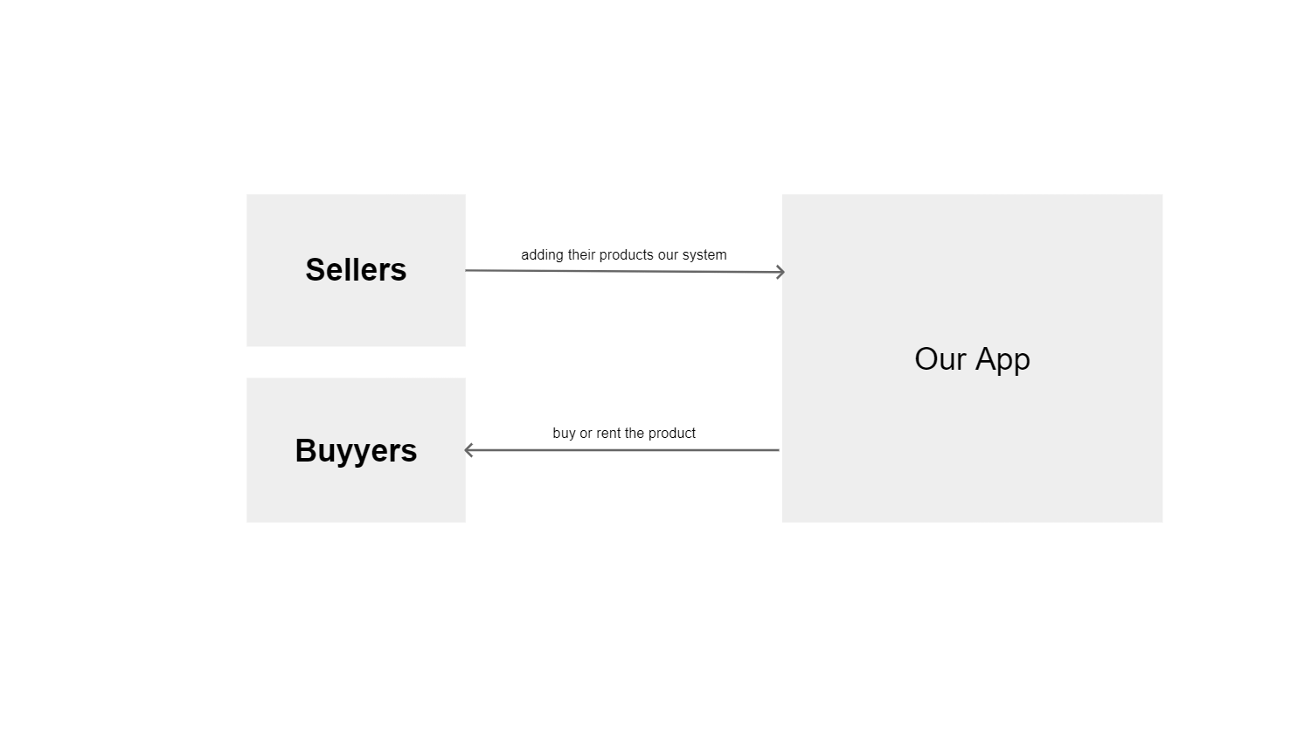

# Project objectives

Today mobile applications have become a major aspect of each business, travel and the development business isn't uncommon example of this. Truly, adaptable application improvement expects an enormous part in the advancement business today. Adaptable applications make it fundamental and energetic to converse with advancement affiliations, book tickets, book rooms and mission for good plans. The utilization of advantageous applications for venturing will expansion and keep making in the coming days

Despite size and classification, all movement organizations and visit administrators make their own movement applications to make the correct game plans for voyagers, and they offer limits and different offices too.

Presently how about we break down certain advantages of movement applications that legitimize that portable applications are vital for your movement and the travel industry business:

Traveling Item Sell and Rent App give all of you helps that your movement needs, for example, area subtleties, ticket booking cost, eatery subtleties, ticket booking office, office to book convenience, taxi, and investigate neighborhood encounters. By routinely making data rich substance on movement thoughts that are sent as pop-up messages can make client faithfulness. (jackluter, 2007)

# Background and motivation

This study investigates the worth of communication in travelling and adventures in life. This brings a outline for research, thesis and introduction the study.

Upcoming parts of the study is background of this research, overview and and we will clarify our objectives, explanation of motivations when joining partners and at last it concludes with the summary of the study.

People all around world studded with busy lives require a beautiful destination to calm up their internal spirits. Travelling the number choice when thinking about a vacation. It is super easy planning your travel just by a click or a tap. World is an ocean of extraordinary places which need to discover and enjoy the beauty hidden without harming them.

Travelling is the most perfect way to enjoy the precious time a human get during a busy lifestyle. When getting the idea for a picnic or a hike or a camping, the people come up with lots of issues. The most important thing is the online platform that we are creating is not only for local travellers but also for whole world.

Issue

Local Sri Lankan travelers do not have any online platform to buy or rent traveling equipment. Hence we are trying to solve this issue by using the newest technology.

# Methodology

## How does your application/solution differ from existing ones

There are many mobile apps regarding travelling in most of them tarvellers can only book hotels , book vehicles needed for travelling purpouses using apps like Booking.com ,uber using individual apps ,so there is a shortage of travelling apps which have travelling items needed for travellers ease of use like renting of vehicles such as bikes ,cars ,three wheelers,.Renting of camping acessories such as camping tents ,camping cooking utilities .Renting of swimming acessories such as snorkles,oxygen tanks,goggles.

From this app travellers can identifiy local places of attractions which are not very popular. This travelling app differs from other applications is the above mentioned all the things can be done by a single app easily.

## Benefits of the app to users

1. Make all the travelling related bookings under one roof
2. Reduced paperwork and can simplifiy travellers transactions
3. Can get real view of the tourist attractions using photos and videos
4. Users can advertise their travelling related business in the mobile application
5. Platform which gives atrractive discounts to travellers
6. Can purchase travelling related items such as camping acessories,swimming accessories
7. Improved services
8. Can receive various information at one device
9. Transactions can be done in a matter of seconds
10. Multiple bookings,purchases can be done by a single app (Booking a hotel and purchasing a camping tent)

## Why do you think this will be a possible solution

Travelling apps rank 5th amongst the most downloaded category of apps globally.Mobile applications are an essential part of the travelling industry in 2020. Mobile applications are fragment of the travel and tourism industry and 2020 will be a huge year for the travelling mobile app development. As the usage and saturation of mobile are high always,so this encourages travel industry owners and mobile app development companies to build apps with the latest trends or technologies. Some important features like travel planning, accommodation booking, cab, and ticket booking, locating viewing and so on are developed by [mobile app development companies](https://www.credencys.com/mobile-application-development-services/) to deliver multi-benefits for users and travel companies. (Sharma, 2020)

# Resource Requirements.

1. Hardware Requirements.

* Processor : Minimum 1 GHZ.
* Internet Connection : LAN or Wifi(wireless).
* RAM : Minimum 2GB.

Can use :-

* Smart Phones.
* Tablets.
* Laptops & Desktops.
* Smart TV s.

1. Software Requirements.

* Integrated development environment used : Android Studio.
* Software Used : Flutter.
* Language Used : C,C++,Dart.
* Platforms : Android & ios.

1. Financial Requirements.
2. Startup Cost.

* Development.
* Legal.(Get Patent Permit)
* Submission.(Apple App Store & Google Play Store)
* Software & Equipment.(Computers,Touchpads,Smartphones & etc.)

1. Ongoing Cost.

* Operations.(Office rents,Internet bills,Insurance and Other bills)
* Marketing.(TV and Radio Commercials,Print media and Social media advertisements)
* Hosting.(Website & App hosting fee)
* Maintenance.(Developing cost,Updates,Security problems and Bugs)

# Project Planner

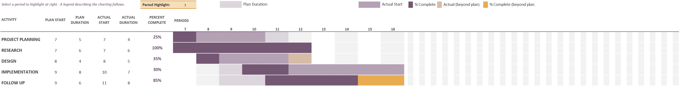

# References

jackluter, 2007. *Benefits of Having a Mobile Apps for Your Travel or Tourism Business.* [Online]   
Available at: https://medium.com/@jackluter/benefits-of-having-a-mobile-apps-for-your-travel-or-tourism-business-cc4c49c04e0a#:~:text=Travel%20applications%20provide%20you%20all,the%20updates%20provided%20on%20weather.  
[Accessed 07 10 2020].

Sharma, S., 2020. *credencys.* [Online]   
Available at: https://www.credencys.com/blog/mobile-app-development-solutions-for-travel-industry/  
[Accessed 29 10 2020].